CT-2 Report
Title: Decision Tree Classification Using Student Performance Dataset

Course title: Data Mining Problem Description

Course code: CSE-452
4th Year 1st Semester Examination 2025

Date of Submission: 14/05/2026

Submitted to-

Md. Humayun Kabir
Professor
Department of Computer Science and Engineering
Jahangirnagar University

&

Dr. Md Musfique Anwar
Professor
Department of Computer Science and Engineering
Jahangirnagar University
Savar, Dhaka-1342

Class Roll | Exam Roll | Name
383 | 210903 | Abdullah Nazmus-Sakib

1. Experiment Name

Design and Implementation of Decision Tree Classification Model Using Student Performance Dataset

2. Objective
The objective of this experiment is to design and implement a Decision Tree Prediction Model for classification using student academic performance data.
The model is trained using GPA-related features and predicts the performance category of students such as:
- Excellent
- Good
- Average
- Poor
The experiment also aims to analyze the classification accuracy and visualize the generated decision tree.

3. Algorithm for Decision Tree Construction

Decision Tree Algorithm Hunt (J48 / C4.5 for formating)
The Decision Tree algorithm works by recursively splitting the dataset based on the most important attribute.

Steps of the Algorithm
- Load the dataset from CSV file.
- Select the best attribute for splitting.
- Divide the dataset into subsets.
- Create decision nodes and branches.
- Continue recursively until all records belong to the same class.
- Generate leaf nodes for final classes.

Attribute Used
- FirstYear GPA
- SecondYear GPA
- ThirdYear GPA
- AVG_Till_Now GPA

Target Class
- Excellent
- Good
- Average
- Poor

4. Pseudocode

Procedure: connectCSV()
procedure connectCSV(file_path)
1: open CSV file
2: read dataset
3: return dataset

Procedure: createNode()
procedure createNode(attribute, threshold)
1: create new node
2: assign attribute and threshold
3: return node

Procedure: split()
procedure split(dataset, feature, threshold)
1: divide dataset into left and right
2: left = feature <= threshold
3: right = feature > threshold
4: return left, right

Procedure: buildTree()
procedure buildTree(dataset)
1: if all data belong to same class
2: return leaf node
3: find best split
4: split dataset
5: recursively build left subtree
6: recursively build right subtree
7: return decision tree

5. Data Sample and Connection

Sample Dataset
FirstYear | SecondYear | ThirdYear | AVG_Till_Now | Performance_Class
3.875 | 4.00 | 1.975 | 3.94 | Excellent
3.32 | 3.87 | 1.95 | 3.656 | Good
3.14 | 3.49 | 1.755 | 3.354 | Average
2.855 | 3.14 | 1.68 | 3.07 | Poor
Total Instances: 52

CSV File Connection
import pandas as pd

dataset = pd.read_csv("student_performance.csv")
print(dataset.head())

6. Python Code

Individual code
class Node:
def __init__(self, feature=None, threshold=None, left=None, right=None, value=None):
self.feature = feature
self.threshold = threshold
self.left = left
self.right = right
self.value = value

def split(dataset, feature, threshold):
left = dataset[dataset[feature] <= threshold]
right = dataset[dataset[feature] > threshold]
return left, right

def build_tree(dataset):
if len(set(dataset['label'])) == 1:
return dataset['label'].iloc[0]

feature = 'AVG_Till_Now'
threshold = dataset[feature].mean()

left, right = split(dataset, feature, threshold)

return Node(
feature=feature,
threshold=threshold,
left=build_tree(left),
right=build_tree(right)
)

Sample complete code code
import pandas as pd
from sklearn.tree import DecisionTreeClassifier
from sklearn import tree
import matplotlib.pyplot as plt

data = pd.read_csv("student_performance.csv")

X = data[["FirstYear", "SecondYear", "ThirdYear", "AVG_Till_Now"]]

y = data["Performance_Class"]

model = DecisionTreeClassifier()

model.fit(X, y)

prediction = model.predict([[3.7, 3.8, 1.9, 3.75]])

print("Predicted Class:", prediction)

plt.figure(figsize=(12,8))
tree.plot_tree(
model,
feature_names=X.columns,
class_names=model.classes_,
filled=True
)

plt.show()

7. Result and Discussion

Obtained Decision Tree

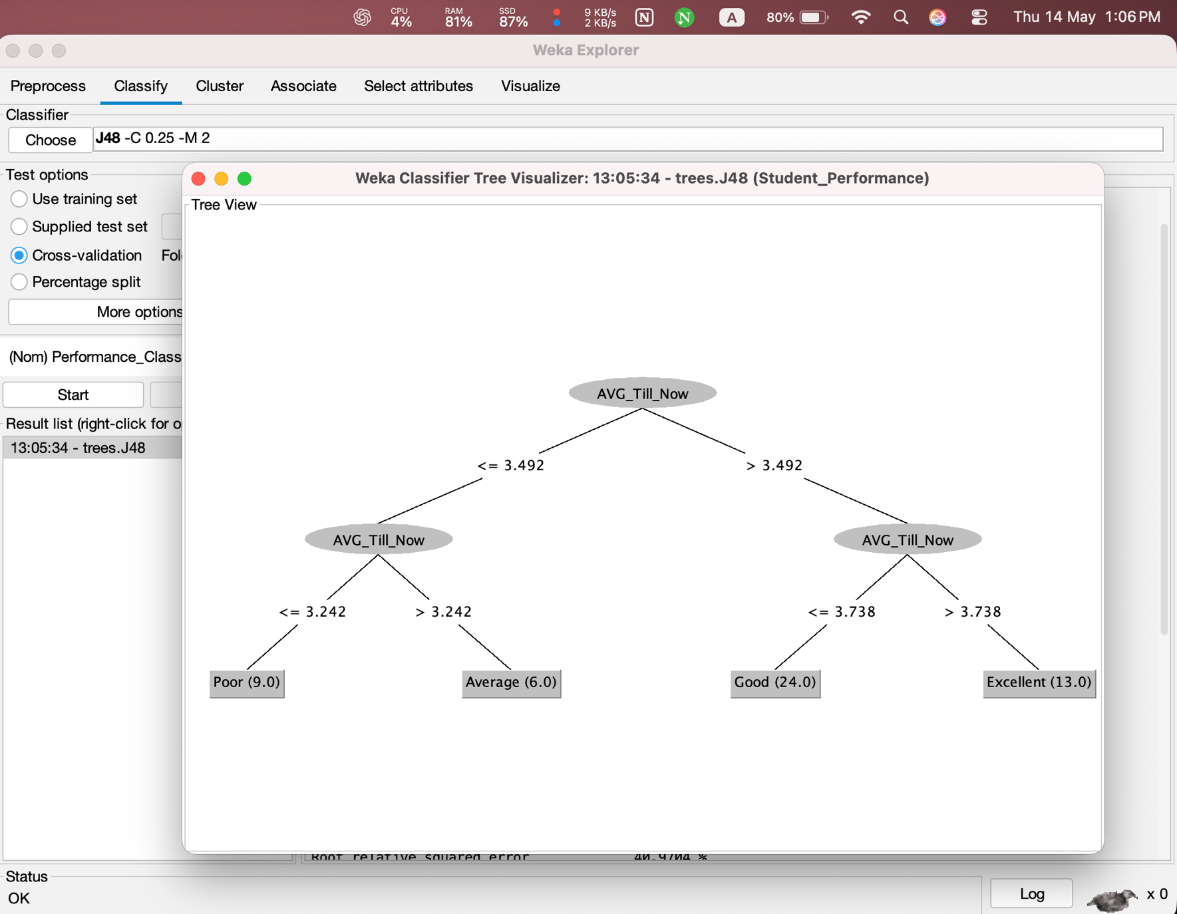

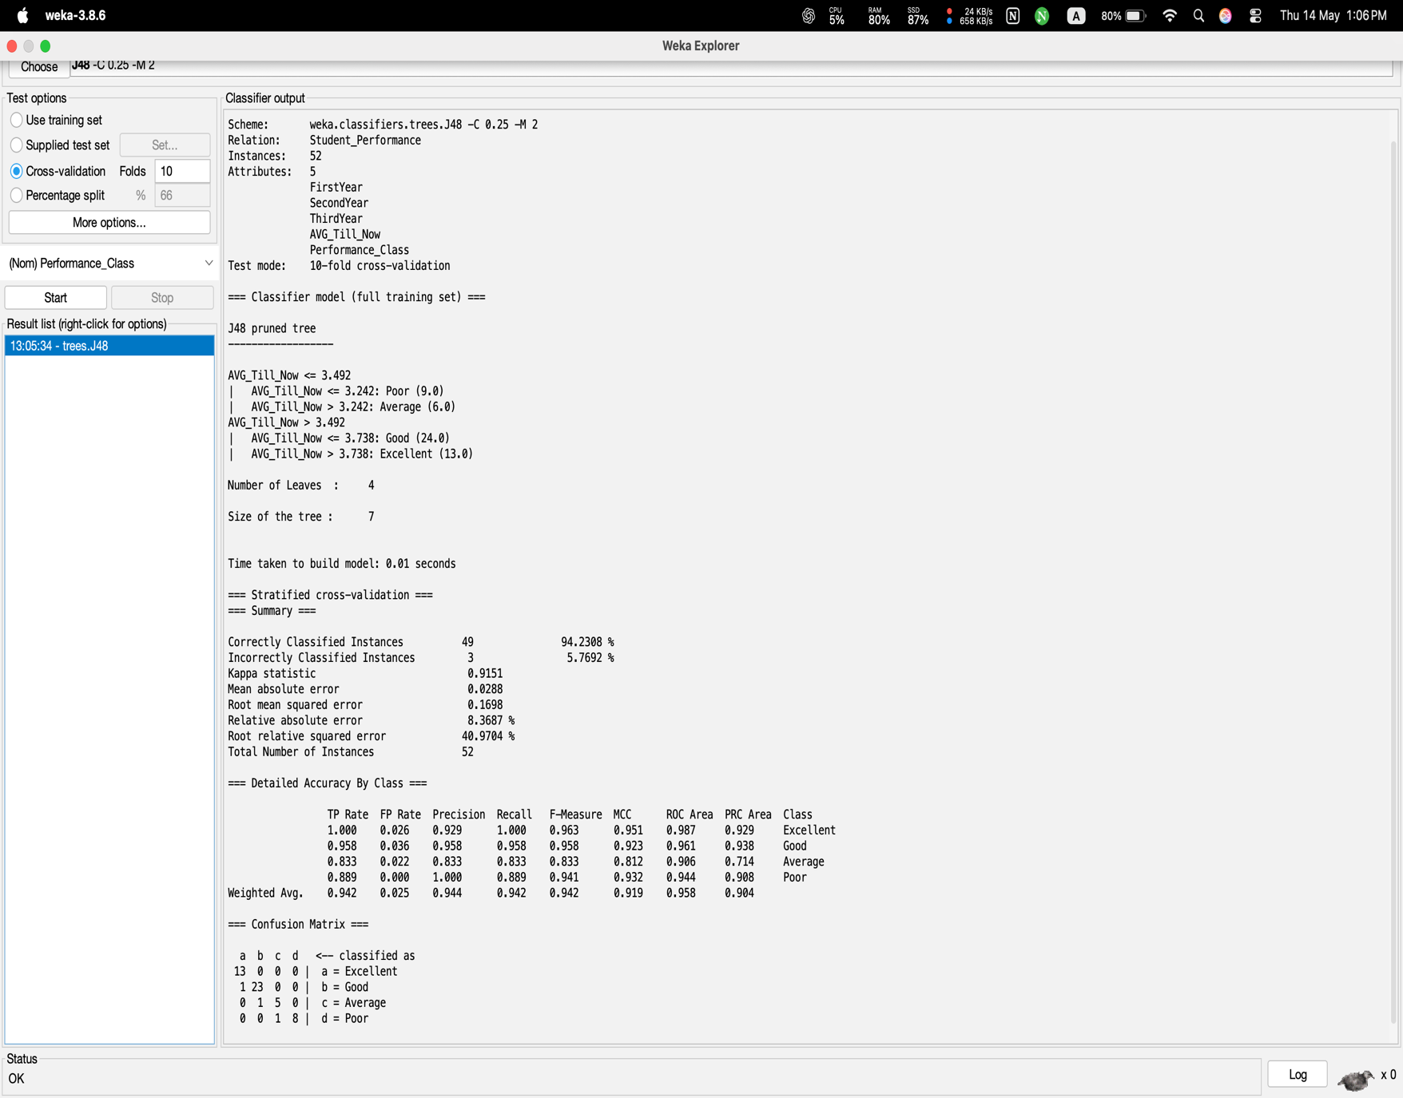

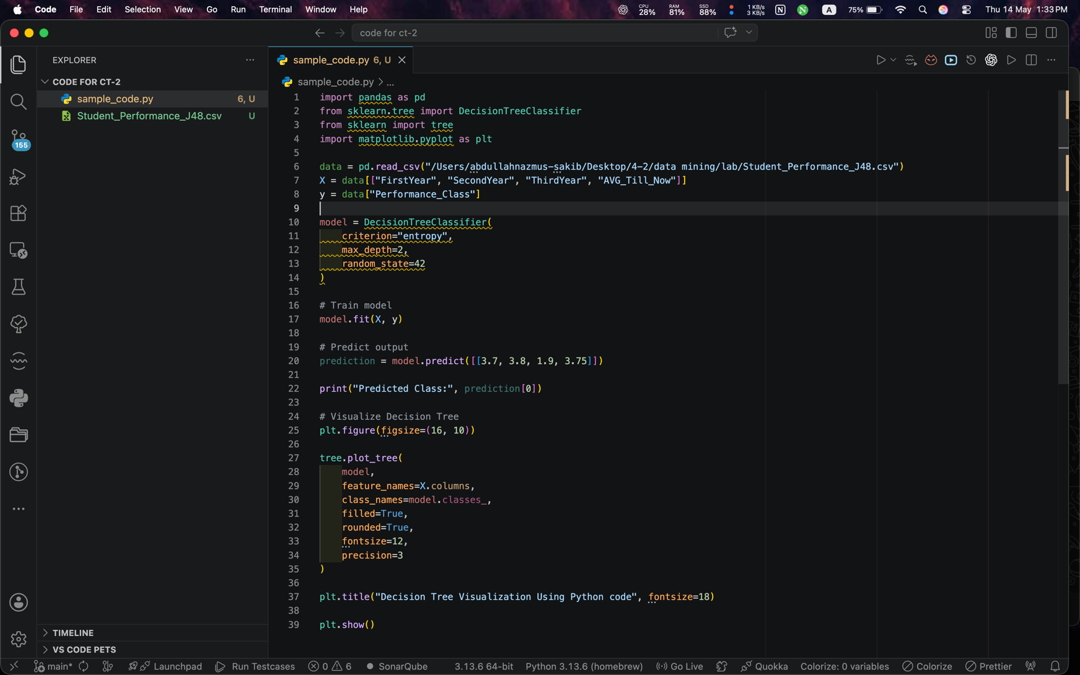

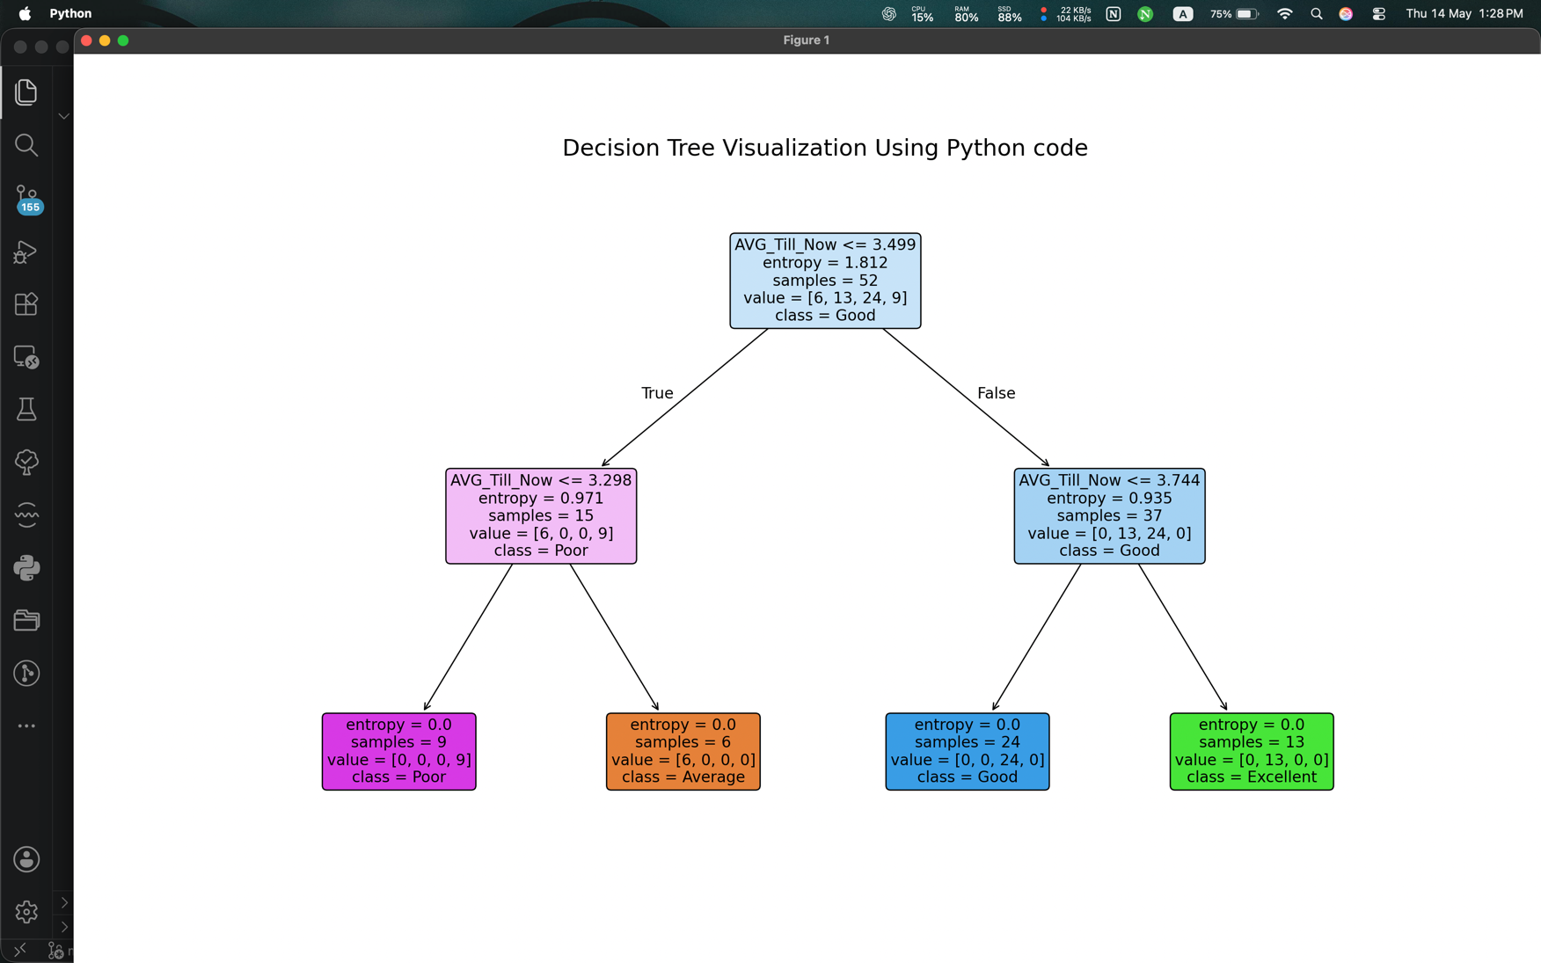

Result Analysis
The Decision Tree model successfully classified student performance based on GPA values.

Performance Summary
- Correctly Classified Instances: 49
- Incorrectly Classified Instances: 3
- Accuracy: 94.23%
- Number of Leaves: 4
- Tree Size: 7
The experiment shows that AVG_Till_Now is the most important attribute for classification.
Students with higher GPA are classified as Excellent, while lower GPA students are classified as Poor.
The model achieved high accuracy and generated an easily understandable decision tree.

